3GPP TSG-RAN WG4 Meeting#119 R4-2606887
Dalian, CN, May 18 - 22, 2026
Agenda item: 8.10.5
Source: ZTE Corporation, Sanechips
Title: Discussion on the impacts of existing requirements and new requirements for 6G sensing
Document for: Approval
- Introduction
In RAN#108 meeting, a new SID on Study on 6G Radio [1] was approved. In this contribution, we would like to share some further understandings on 6GR ISAC study.
- Sensing – Studies to be based on use cases and associated requirements, as defined in [TR38.914]
- PHY functions and procedures for sensing technology (e.g., waveform. reference signals, measurement feedback, etc…) [RAN1, RAN4]
- Evaluate sensing performance and if necessary, extend channel modelling, for the selected use cases [RAN1]
- Aspects of integration with communication services [RAN1]
- higher layer procedures and protocol aspects [RAN2]
- RAN4 aspects of sensing including RF, coexistence, and testability in coordination with other WGs [RAN4]
Note: RAN1 identify detailed requirements, if triggered by TSG RAN
RAN4#116bis:
Agreement:
Before April 2026, the agenda for sensing will be kept. RAN4 discussion will primarily focus on the following aspect
- Sensing related regulatory status and requirement survey
- Potential architecture consideration based on the RAN plenary use case study
- views sharing on the potential RAN4 scope based on the identified use cases out of RAN plenary study
- Identify less RAN1 design dependent RAN4 aspects if any

- Discussion

2.1. The impacts on the existing RF requirement for 6G sensing
There are 7 different sensing mode as discussed in the previous RAN plenary meeting, from our understanding, different sensing mode would have different applicable RF requirement, therefore we propose to discuss these issue case by case as shown in the following table 2.1-1 instead of merging together.
Table 2.1-1: The expected impacted RF requirement for different sensing mode
Sensing mode | Tx | Rx
TRP mono-static | TRP Tx requirement is needed | TRP Rx requirement is needed
TRP bi-static | TRP Tx requirement is needed | TRP Rx requirement is needed
TRP-UE bi-static | TRP Tx requirement is needed | UE Rx requirement is needed
UE-TRP bi-static | UE Tx requirement is needed | TRP Rx requirement is needed
UE monostatic | UE Tx requirement is needed | UE Rx requirement is needed
UE bi-static | UE Tx requirement is needed | UE Rx requirement is needed
Proposal 1: For the impacts on the existing RF requirement, propose to discuss the sensing mode case by case.

In the following table 2.1-2, we provide some initial view on the applicable requirements for 6G TRP moon-static sensing mode comparing to 6GR BS RF requirements.
Table 2.1-2: General view on the relationship between 6GR BS and 6G TRP mono-static requirement
 | 6GR BS | 6G ISAC
carrier bandwidth | Yes | The same as 6GR BS
Numerology | Yes | FFS
Channel raster | Yes | FFS
Sync raster | Yes | N/A
Base station output power | Yes | Accuracy is expected to be the same as 6GR BS
Output power dynamics | Yes | N/A
Transmit ON/OFF power | Yes | FFS  For full duplex sensing TRP solution, it might be slightly different compared with TDD BS.
Transmitted signal quality | Yes | FFS  It depends on the design of sensing signal
OBW | Yes | The same as 6GR BS
Tx intermodulation | Yes | The same as 6GR BS
ACLR | Yes | Expected to be the same as communication DL if DL spectrum is used for sensing transmission.
Operating band unwanted emissions | Yes | Expected to be the same as communication DL if DL spectrum is used for sensing transmission.
Transmitter spurious emissions | Yes | The same as 6GR BS
Rx part
REFSENS | Yes | E.g.distance, angle estimation and velocity estimation for UAV
dynamic range | Yes | FFS
ACS | Yes | Depends on coexistence study
blocking | Yes | Depends on coexistence study
NBB | Yes | FFS
RX IMD | Yes | Depends on coexistence study
RX NB IMD | Yes | FFS
RX spurious emission | Yes | The same as 6GR BS
RX ICS | Yes | FFS

2.2. Potential new requirements for 6G sensing
There are 6 different sensing mode as discussed in the previous RAN plenary meeting, from our understanding, different sensing mode would have different applicable RF requirement, therefore we propose to discuss these issue case by case as shown in the following table 2.1-1 instead of merging together.
Table 2.2-1: The expected new RF requirements for different sensing mode
Sensing mode | Tx | Rx
TRP mono-static | TRP Tx requirement is needed  - Tx quality for sensing signal if needed;  - Fast ON-OFF transition period for switching between transmission and reception of sensing slot if needed | TRP Rx requirement is needed  - REFSENS requirements (e.g. miss detection/false alarm detection probability) for sensing signal  - Other ACS/IBB blocking requirement due to the BS2BS CLI interference if exists
TRP bi-static | TRP Tx requirement is needed  - Tx quality for sensing signal if needed; | TRP Rx requirement is needed  - REFSENS requirements (e.g. miss detection/false alarm detection probability) for sensing signal  - Other ACS/IBB blocking requirement due to the BS2BS CLI interference if exists  - Tight timing sync requirement between Tx and Rx
TRP-UE bi-static | TRP Tx requirement is needed  - Tx quality for sensing signal if needed; | UE Rx requirement is needed  - REFSENS requirements (e.g. miss detection/false alarm detection probability) for sensing signal  - ACS/IBB with the sensing signal as wanted signal with certain degradation  - Potential large receiver dynamic range requirements
UE-TRP bi-static | UE Tx requirement is needed  - Tx quality for sensing signal if needed; | TRP Rx requirement is needed  - REFSENS requirements (e.g. miss detection/false alarm detection probability) for sensing signal  - ACS/IBB with sensing signal as wanted signal with certain degradation  - Potential large receiver dynamic range requirements
UE monostatic | UE Tx requirement is needed  - Tx quality for sensing signal if needed;  - Fast ON-OFF transition period for switching between transmission and reception of sensing slot if needed | UE Rx requirement is needed  - REFSENS requirements (e.g. miss detection/false alarm detection probability) for sensing signal  - Other ACS/IBB blocking requirement due to the UE2UE CLI interference if exists
UE bi-static | UE Tx requirement is needed  - Tx quality for sensing signal if needed; | UE Rx requirement is needed  - REFSENS requirements (e.g. miss detection/false alarm detection probability) for sensing signal  - Other ACS/IBB blocking requirement due to the UE2UE CLI interference if exists
Proposal 3: For the potential new RF requirement for 6G sensing, propose to discuss the sensing mode case by case.

2.3. RRM requirement impacts for 6G sensing
Similar to Rel-17 positioning WID as shown in Figure 2.2-1, for 6G sensing, it might be also necessary to define the certain RRM requirement at receiver side to verify the sensing accuracy requirement, however these details is highly dependent on RAN1’s physical layer and framework design. We propose to postpone the discussion until there are sufficient progress made in RAN1/RAN2/RAN3.
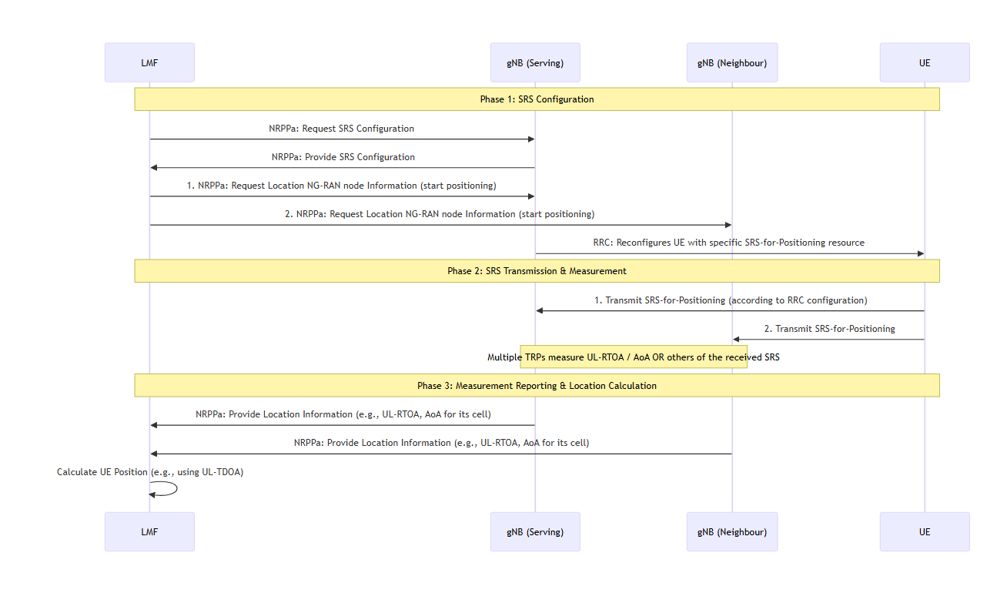
Figure 2.2-1. Illustration of Rel-17 positioning framework
Regarding the measurement results defined in RAN1 and the corresponding measurement accuracy requirement defined in RAN4, at least from our understanding, it is highly dependent on which level of measurement results to be reported. In the 5G-A phase for UAV detection, we have the following different level of measurement results to be reported as shown in Figure 2.2-2. Level A and Level B is somehow the physical channel level of measurement results to be reported. For Level C and Level D, the physical channel level (CIR) of results has been processed into the cloud point or trajectory information to be reported.
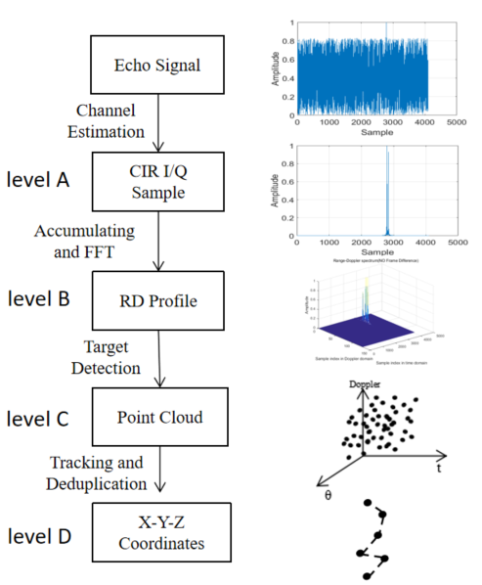
Figure 2.2-2. The illustration of different level of measurement results to be reported for 5GA ISAC for UAV
In addition, in the previous RAN4 meetings, there were some RRM related proposals other than measurement accuracy e.g. measurement gap for sensing reception for UE involved sensing mode and how the sensing measurement impacts on the legacy the RRM measurement, from our understanding, we need to draw the initial conclusion on sensing mode and also sensing signal design firstly, then RAN4 can further discuss the RRM impacts due to the sensing signal.
Proposal 4: For the communication RRM impacts due to 6G sensing measurement, propose to postpone the discussion until there are sufficient progress made in RAN1/RAN2/RAN3.
- Conclusions
In this contribution, we shared some initial views on the 6GR TRP sensing mode study and proposals are made as follows:
Proposal 1: For the impacts on the existing RF requirement, propose to discuss the sensing mode case by case.
Sensing mode | Tx | Rx
TRP mono-static | TRP Tx requirement is needed | TRP Rx requirement is needed
TRP bi-static | TRP Tx requirement is needed | TRP Rx requirement is needed
TRP-UE bi-static | TRP Tx requirement is needed | UE Rx requirement is needed
UE-TRP bi-static | UE Tx requirement is needed | TRP Rx requirement is needed
UE monostatic | UE Tx requirement is needed | UE Rx requirement is needed
UE bi-static | UE Tx requirement is needed | UE Rx requirement is needed
Proposal 2: For the TRP mono-static sensing mode, propose to consider the following RF requirements for TRP mono-static sensing mode;
RF requirements | 6GR BS | 6G ISAC
carrier bandwidth | Yes | The same as 6GR BS
Numerology | Yes | FFS
Channel raster | Yes | FFS
Sync raster | Yes | N/A
Base station output power | Yes | Accuracy is expected to be the same as 6GR BS
Output power dynamics | Yes | N/A
Transmit ON/OFF power | Yes | FFS  For full duplex sensing TRP solution, it might be slightly different compared with TDD BS.
OBW | Yes | The same as 6GR BS
Tx intermodulation | Yes | The same as 6GR BS
ACLR | Yes | Expected to be the same as communication DL if DL spectrum is used for sensing transmission.
Operating band unwanted emissions | Yes | Expected to be the same as communication DL if DL spectrum is used for sensing transmission.
Transmitter spurious emissions | Yes | The same as 6GR BS
Rx part
dynamic range | Yes | FFS
NBB | Yes | FFS
RX NB IMD | Yes | FFS
RX spurious emission | Yes | The same as 6GR BS
RX ICS | Yes | FFS
Proposal 3: For the potential new RF requirement for 6G sensing, propose to discuss the sensing mode case by case.
Sensing mode | Tx | Rx
TRP mono-static | TRP Tx requirement is needed  - Tx quality for sensing signal if needed;  - Fast ON-OFF transition period for switching between transmission and reception of sensing slot if needed | TRP Rx requirement is needed  - REFSENS requirements (e.g. miss detection/false alarm detection probability) for sensing signal  - Other ACS/IBB blocking requirement due to the BS2BS CLI interference if exists
TRP bi-static | TRP Tx requirement is needed  - Tx quality for sensing signal if needed; | TRP Rx requirement is needed  - REFSENS requirements (e.g. miss detection/false alarm detection probability) for sensing signal  - Other ACS/IBB blocking requirement due to the BS2BS CLI interference if exists  - Tight timing sync requirement between Tx and Rx
TRP-UE bi-static | TRP Tx requirement is needed  - Tx quality for sensing signal if needed; | UE Rx requirement is needed  - REFSENS requirements (e.g. miss detection/false alarm detection probability) for sensing signal  - ACS/IBB with the sensing signal as wanted signal with certain degradation  - Potential large receiver dynamic range requirements
UE-TRP bi-static | UE Tx requirement is needed  - Tx quality for sensing signal if needed; | TRP Rx requirement is needed  - REFSENS requirements (e.g. miss detection/false alarm detection probability) for sensing signal  - ACS/IBB with sensing signal as wanted signal with certain degradation  - Potential large receiver dynamic range requirements
UE monostatic | UE Tx requirement is needed  - Tx quality for sensing signal if needed;  - Fast ON-OFF transition period for switching between transmission and reception of sensing slot if needed | UE Rx requirement is needed  - REFSENS requirements (e.g. miss detection/false alarm detection probability) for sensing signal  - Other ACS/IBB blocking requirement due to the UE2UE CLI interference if exists
UE bi-static | UE Tx requirement is needed  - Tx quality for sensing signal if needed; | UE Rx requirement is needed  - REFSENS requirements (e.g. miss detection/false alarm detection probability) for sensing signal  - Other ACS/IBB blocking requirement due to the UE2UE CLI interference if exists
Proposal 4: For the potential communication RRM impacts or sensing measurement accuracy due to 6G sensing measurement, propose to postpone the discussion until there are sufficient progress made in RAN1/RAN2/RAN3.
- References
- RP-251881,New SID: Study on 6G Radio, Approved.
- RP-251742, Study on 6G scenarios and requirements - ISAC, ZTE,
- R1-2506131,Discussion on 5G-A ISAC evaluation,ZTE, Noted.
- RP-252024 RAN KPIs for IMT-2030
- R4-2602286 WF on 6G sensing, approved.

